**JSON**

* **JSON** stands for javascript object notation.
* **JSON** it is based on javascript syntax.
* **JSON** is a syntax for storing and exchanging data.
* **JSON** is self describing and easy to understand.
* **JSON** islanguage independent.
* **JSON** can be used to store application data.
* **JSON** is data interchange format like **xml**.
* **JSON** is better than xml.
* **JSON** is light weight than xml.

**XML DATA FORMAT**

<id>3</id> (10 characters)

**JSON DATA FORMAT**

{“id”:3} (8 characters)

* Json has more readability than xml.
* Json Has 3 Main Advantages Over Xml.
  + Light Weight
  + More Readable
  + 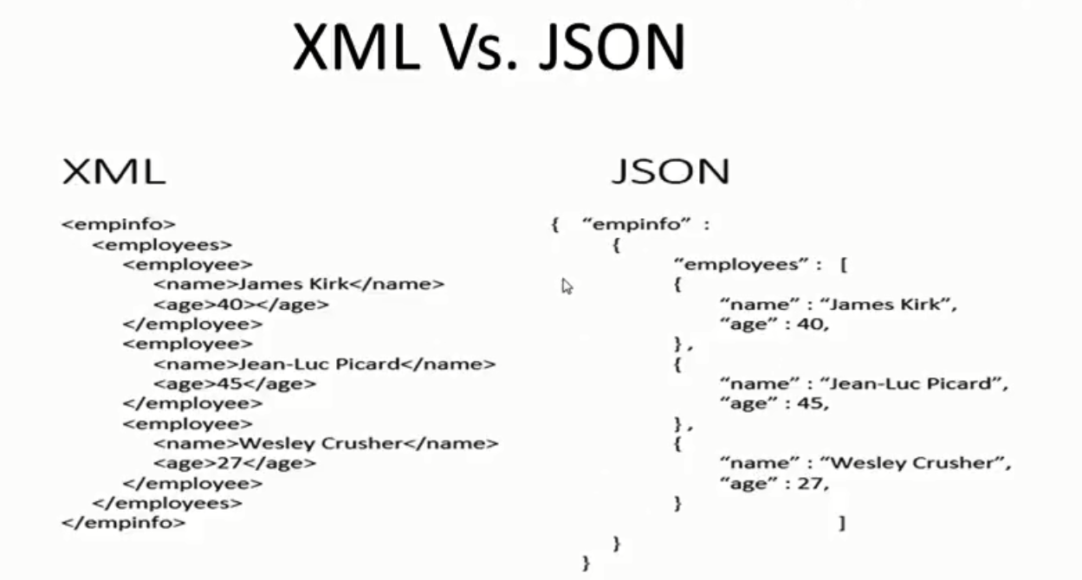Easy To Parse

**Why Use Json?**

Since the JSON format is text only, it can easily be sent to and from a server, and used as a data format by any programming language.

**Exchanging Data**

* When exchanging data between a browser and a server, the data can only be text.
* JSON is text, and we can convert any JavaScript object into JSON, and send JSON to the server.
* We can also convert any JSON received from the server into JavaScript objects.
* This way we can work with the data as JavaScript objects, with no complicated parsing and translations.

**Sending Data:**

If you have data stored in a JavaScript object, you can convert the object into JSON, and send it to a server.

**Receiving Data:**

If you receive data in JSON format, you can convert it into a JavaScript object.

**SERVER**

**CLIENT MACHINE**

**(BROWSER)**

**REQUEST**



**JSON**

**RESPONSE**